

|  |  |  |  |  |  |  |  |  |
| --- | --- | --- | --- | --- | --- | --- | --- | --- |
|  | | | | | | | | |
|  | | BGMI Management SQL Project | | | | |  | |
|  |  | | | | | | |  |
|  | | | |  |  | | | |
|  | | | | *Name: Rahul Ajay Gudekar* |  | | | |
|  | | | | Course titleTo managing the data of BGMI community for that I created a database called BGMI Management SystemTeacher’s name *Jayesh Patil sir* |  | | | |
|  | | |  | | |  | | |



|  |  |  |  |  |  |  |  |  |
| --- | --- | --- | --- | --- | --- | --- | --- | --- |
|  |  | | |  |  | | |  |
|  | BGMI Management | | | | | | |  |
|  |  | | |  |  | | |  |
|  |  | |  | | |  | |  |
|  |  |  | Introduction :  To track the record of the BGMI players with respect to there Rankings, Name, In game role also there belonging Teams Names we created a database called BGMI Management System | | |  |  |  |
|  | | | | |
|  |  |  |  |
|  |  |



|  |  |  |  |  |  |  |  |  |
| --- | --- | --- | --- | --- | --- | --- | --- | --- |
|  | |  |  | | |  |  | |
|  | | Creation and insertion of table | | | | |  | |
|  | |  |  | | |  |  | |
|  | create table Team(Team_id int not null,Team_name varchar(50) unique,Coach varchar(50) not null,Country varchar(50)); | | | | | | |  |
|  | Select * from team; | | |  |  | | |  |
|  |  | | |  |  | | |  |

|  |  |  |  |  |  |  |
| --- | --- | --- | --- | --- | --- | --- |
|  |  | | | | |  |
|  | |  |  |  |  | |
|  |  | | | | |  |

create table Player(

Player_id int not null,

name varchar(50),

Role varchar(50) not null,

current_Team varchar(50));

select * from player;

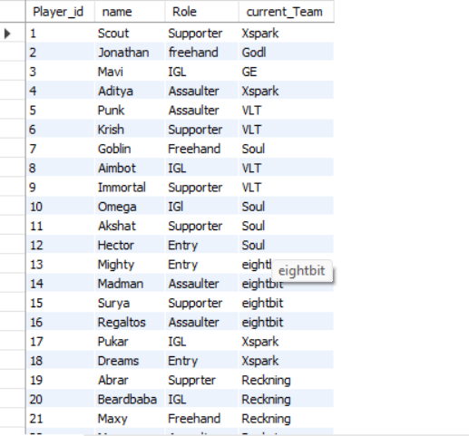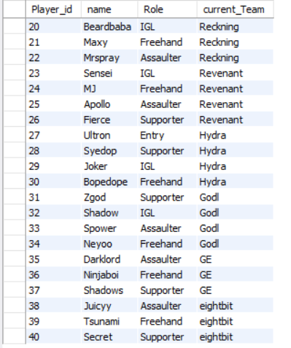

Create table Fixtures(

Match_id int primary key auto_increment,

Team1 varchar(50) not null,

team2 varchar(60),Toss_winnner varchar(50),,Match_winner varchar(50));

select * from fixtures

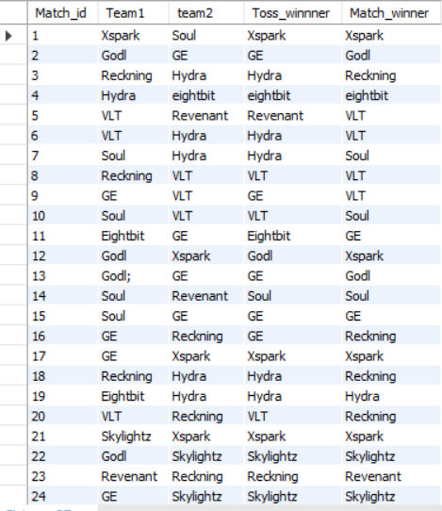

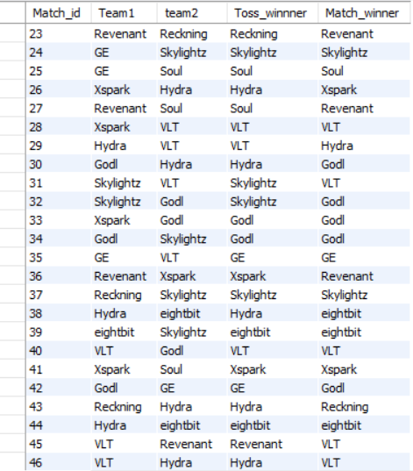

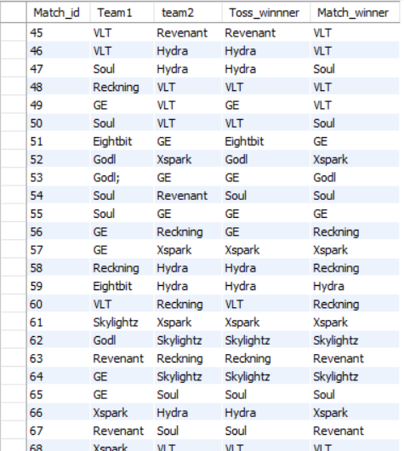

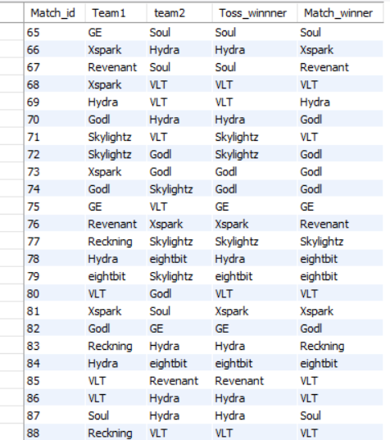

create table Assaulter(

Ranking int not null,

Player_name varchar(50) primary key,

Kills int not null,

Eliminations varchar(50) not null);

Select * from Assaulter;

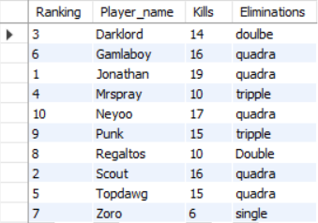

create table Entry_Fragger(

Position int ,

Player_name varchar(50) primary key,

Frags int ,eliminate varchar(50)); select * from entry_fragger; 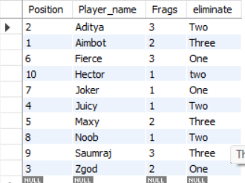

Joins

#display players with respect to there team names also country as well as what are the roles of the players .

select team . team name as tname , team.country as country_name,player.name as Pname,player.role as Role_name

from team join player

on team.team_id=Player.Player_id;

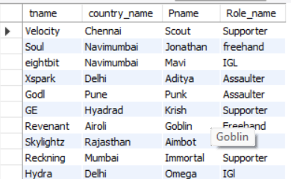

#display assaulters details with respect to their team_names,rankings and kills

select player.name as Player_name,player.role as Player_role,assaulter.ranking as Player_ranking,assaulter.kills as player_kills

from player Right join assaulter

on player.player_id= Assaulter.ranking;

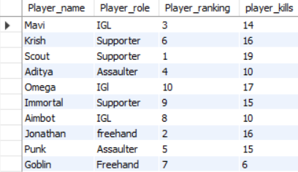

#display player names who are assaulter as well as entry fragger

select entry_fragger.player_name as fragger_name,entry_fragger.frags as player_frags,assaulter.player_name as assaulter_name,assaulter.kills as assaulter_kills

from entry_fragger join assaulter

on entry_fragger.position=assaulter.ranking;

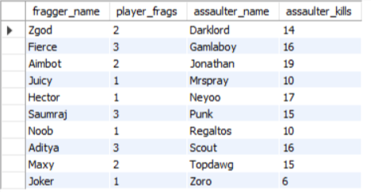

Subquery

#write a subquery to find who has highest frags in entry_fragger table

select max(frags) from entry_fragger;

select * from entry_fragger

where frags =(select max(frags) from entry_fragger);

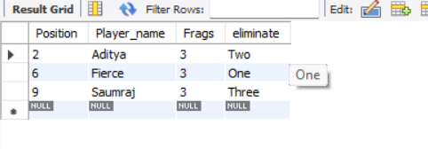

#to find who has quadra emlimination in assaulter table

select eliminations from assaulter where player_name='Gamlaboy';

select * from assaulter where eliminations in (select eliminations from assaulter where player_name='Gamlaboy');

